ICCX Europe 2011 Conference Program
TIPAS – The International Precast Associations Summit, Day 2
7th October 2011, ICCE, Bologna, Italy

How To Grow An Association
New Member Recruitment

Results of Workgroup Exercises

1. Recruitment Planning

1.1 Recruitment Research
1.2 Targets & Benefits
1.3 New Issues & Trends To Consider
1.4 Appealing To Young Members
1.5 Catalyst For Joining

2. Services & Benefits Provided

2.1 For the Good of the Community
2.2 For the Member

3. Association Success Stories

3.1 Publishing The ‘Little Book of Concrete” (UK)
3.2 Webinars (USA)
3.3 Amendments to Holocore (Denmark)
3.4 Conferring Status (???)
3.5 Various (Finland)
3.6 Re-Organisation (Australia)

4. Future Activity

4.1 Content Availability (Australia)
4.2 Communications (South Africa)

Workshop Presenter & Draft Notes Complied By
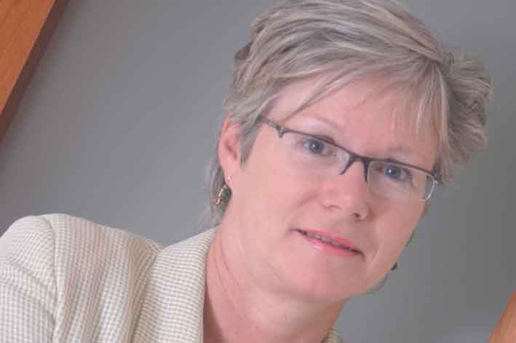
Sue Froggatt
Membership Training, Consulting, Research & Meeting Facilitation

Email: sue@suefroggatt.com
Web: www.suefroggatt.com
Telephone: 00 44 870 747 9185

These are D R A F T notes

Please can you:

- CONFIRM THESE POINTS

- ADD MISSING INFORMATION

3. HAVE A GENERAL READ THROUGH & CORRECT/CLARRIFY POINTS

Thanks!
1. Recruitment Planning

1.1 Recruitment Research

What questions do you need answered before you can develop a member recruitment strategy and plan? Who needs to answer the questions you have outlined i.e. members, non-members, etc?

- Do we want new members? Why do we need or not need new members? Ask the board and staff.
- If we need new members:
  - Who do we want in membership?
  - What benefits will appeal most?
  - What is the value proposition?
Ask non-members to verify. Also ask members, existing members and staff.

- How else can we connect and communicate with non-members? Ask them how they could they contribute (for the ‘good of the community’) – without joining.

- What are the strengths, weaknesses, opportunities and threats? (SWOT analysis)
- What do members want? What are the different needs of different types of members e.g. large and small? (NB: Do they know?)
- What worries do they have?
- Who are we competing with and what are they offering? (Other associations and organisations.)

- Who makes/influences the decision to join?
- What is the hierarchy within the organisation?
- What are the internal politics to consider?
- What personality and social issues (rational and irrational) do we need to consider?

NB: Also ref Sue’s handout in the pack:

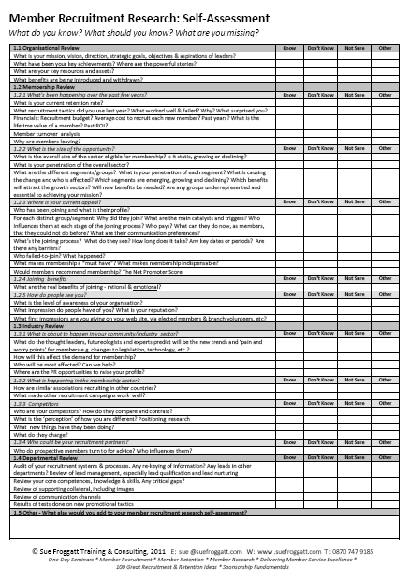

1.2 Targets & Benefits

What different types of organisations would membership appeal to? What benefits (or experiences) appeal most to each group you have identified?

Type of Organisation | Key Benefits – What are most they interested in?
Producer / Manufacturer  CORE MEMBERSHIP CATEGORY | All  - Growing the sector and growing their market share within the sector  - Representation  - Profitability  - Corporate responsibility – understanding their liabilities  - Competition compliance – so they don’t get into trouble  - That we show an an understanding of their own specific sector e.g. roof tiles  For larger organizations:  - Legitimacy  - Dominance  For smaller organizations  - Value for money  - Growth  - Assistance
Suppliers to manufacturers  Associate members  Supply chain members | - Access to producers i.e. selling opportunities  - Social events e.g. golf days  - Sponsorship & advertising opportunities  - Bulk purchasing opportunities  - Information about members and the market  - One-to-one confidential talks about their specific problems i.e. being loved and cherished!
Contractors (& Subcontractors) | - Quality recognition  - Competency forum  - Education and training
Specialist Consultants  E.g. Builders, Architects  Specifiers | - Independent information
Government Authorities | - Independent information
Allied Associations | - Information?  - Joint subscription arrangements?  NB:: This includes similar associations in other countries and other construction associations e.g. steel re-enforcement, block paving, etc.
Academic  Educational Institutions  Schools, Universities & Colleges | - Information for students  - Work placements for students  - Research projects  - Lecturers for speaking  - Publications  - Forums
Individuals | - Industry information
Other

- Related – not in the pre-cast concrete industry, but in the same supply chain e.g. cement companies, chemical companies, etc - Might be supportive members

1.3 New Issues & Trends To Consider

How are the needs and experiences of members changing e.g. use of technology/social media/etc? What impact will this have on your recruitment plan? Will any new benefits be needed?

- New technology & technical issues
- Make use of QR codes – to link people directly to your web site via smart phones
- RFID
- Chips

- Use of new communications media i.e. social media – need to use/understand/be involved in (e.g. now new members are becoming aware of the association by Twitter (ref. UK))

- Marketing and PR issues are becoming more important – so need to become more customer service orientated

- Product stewardship i.e. recycling at end of life

- Time poverty – so members will need quick and reliable answers

Impact of the recruitment plan:

- Associations must evolve to remain current

1.4 Appealing To Young Members

What do associations need to do to ensure they attract and appeal to younger members (Generation Y)? How can you ensure a greater understanding of the experiences, outlooks and motivations of the different generations?

- Use social media to help create awareness of the association (for marketing and PR)
- Start up more social groups for younger people (and women) e.g. Facebook groups (ref. Portugal)
- Put information/start a channel on YouTube
- Use Twitter (see above)

- Focus on:
- Environmental groups/issues – help them to think concrete (enabled longer life spans), not timber (full of chemicals and deforestation)
- Technical groups/issues – young people are active – good opportunity to find out how they are thinking

- Introduce the technology they are familiar with
- QR codes
- Mobile phone ‘App’ for careers

- Change perceptions – away from ‘old boys club’

Comment

- Observation: ‘Father to son issue’: When family business is taken over by children/son, the father is told to focus on association, while son works on the business. So the danger is that the association will appear full of older members and the risk is the link with the next generation will be lost.

1.5 Catalyst For Joining

What situations and issues act as catalysts and trigger an interest in taking a look at membership?

  - Legal problem or contractual issue that is/might go to court, so they need help from someone who understands.
  - Approach because they offer a few (4) hours free legal advice - but then have to pay for
  - Useful to set up a separate organisation - so seen as impartial and independent
  - This can generates significant revenue
  - There is a growing demand for this service
  - There is a lack of experts to give evidence in pre-cast concrete
  - Big contractors have lawyers to represent them, smaller organisations have no such help
  - Ref: Norway, Germany & Australia

- Need an outsider to point out something is wrong and the member does not want to be seen as them because they might loose goodwill (a delicate issue)

- Need help with a staff or technical issue and offer free advice

- Interest in introducing new technology e.g. BIM

- Need for benchmarking for new product

- Sustainability issue – how it might affect them

- Natural disasters & accidents

- New and changing standards and codes

- A shortage of commodities

- Legislation and lobbying opportunity

- The opportunity to connect with and contact other organisations

- Recommended by a colleague

- Member bought a new member along with them (NB: This resulted in creating tension, so they had to create another group!)

- Business expansion

- Need to hire new staff – lost expertise within company

- Business downturn

- To use a member to empower his voice
2. Benefits & Services Provided

What benefits do you offer?

NB: I have reorganised the list that was generated into benefit type and:

- Benefits for the community and
- Benefits that are focused specifically on members

I trust this proves useful.

NB: This information is also available as a spreadsheet – so you can re-sort and customise as needed.

2.1 Benefits For the ‘Good of the Community’ (Members & Non Members)

Type | Description | More Details | Ref No
Lobbying | At the European Level | Federation | 8
Lobbying | Representation |  | 18
Quality Mark | Compulsory charter scheme | Covers safety, legal, health & safety, sustainability, etc. Ref www.bpfc.charter.com | 32
Standards Development | Standards/standardisation | Have 72 available on a European level | 7 & 19
Standards Development | Translation of standards |  | 10
Community Development | Building relationships with other Associations | E.g. Structural Designers | 36
Service - Business Performance Improvement | Free/Fee calculation programs | Available for everyone i.e. members and non-members | 12
News | Twitter | Carry member tweets. NB: The UK has achieved 1,300 followers. | 53
Information | Web site |  | 43

2.2 Benefits Mainly/Only For The Member

Type | Description | More Details | Ref No
Education & Training | Seminars | e.g. For Civil Engineers | 6 & 22 & 28
Education & Training | Webinars & eLearning (online courses) |  | 20
Education & Training | Training & competence |  | 42
Education & Training | Safety workshops | Highlight best and worst practice, tips and slips, etc | 43
Education & Training | Site and factory visits | For members only | 44
Education & Training | Trade exhibitions & conferences | Question: Should associations do? Some offer logo (for support), others buy block space (almost at cost) for members to use (minimum profit) and others don't get involved. | 40
Education & Training | Connection to industry body of knowledge |  | 31
Networking | Facebook site |  | 11
Networking | Networking |  | 9
News | Daily news alert | Ebulletin | 45
News | Quarterly technical bulletin | Technical information | 46
Publications | Magazine | For architects, professionals in industry, authorities, students, health & safety, environment, work installations, planning tools | 14
Publications | Magazine supplements | Co-ordinating by advertising | 52
Publications | Design guide |  | 16
Publications | Design manual |  | 26
Publications | PCC Handbook |  | 1
Publications | Walling Detail Manual |  | 3
Publications | Yearbook | Distributed to practioners | 48
Recognition - Awards | For excellence |  | 21
Recognition - Awards | Lifetime achievement |  | 47
Recognition - Certification | Certification | In collaboration with the Government Standards Agency | 15 & 29
Recognition - Certification | EDP Certification & Verification Service | The association pays €9,000 and all members get for free - would have cost them €1,000 if they paid individually. (Environmental Product Declaration) | 37
Service - Business Performance Improvement | Benchmarking | Includes staff, finance, safety, quality, etc. Issue is the number of people participating can be low. | 44
Service - Business Performance Improvement | Best practice |  | 27
Service - Business Performance Improvement | Standard delivery terms for execution of works |  | 25
Service - Business Performance Improvement - Research | Common research & development |  | 38
Service - Business Performance Improvement - Research | Detailed statistics | Including prices | 13
Service - Advice | Expertise Service |  | 4
Service - Cost reduction | Group/collective buying | Includes materials (concrete), access to patents. | 41
Service - Cost reduction | Access to 200 Standards | Agreement with National Standards Institute. Includes standards and updates. Would cost members individually €400 to buy, but they get for free as members. | 39
Service - Cost reduction | Group subscription to Public ??? | Members get a discount | 30
Service - Customer Intelligence | Credit circle - shows the financial health check of current or prospective clients | Access to a 24*7 database which shows the financial position of organisations. Helps members manage/spread risk. Costs the association £1k, makes no revenue from and member take-up is low. | 33
Service – Funding*1 | Grant finder scheme | A tailored service for members to so they can search for grants for loans available around the world. | 35
Service - Guidance | Sandwich Panel Recommended Practice |  | 2
Service - Legal | Legal Representation | Free for some, Fee for others | 5
Service - Moderation | Moderation | Assist with negotiations with trade unions | 49
Service - Sales & Marketing | Collective advertisements |  | 50
Service - Sales & Marketing | Early notification/warning/alert of business opportunity*1 | In constant telephone contact with municipality of region (local government) to find out where they are planning to invest, so members find out before information is published. | 24
Service - Sales & Marketing | Collective product promotion*1 | Includes brochures, seminars, videos and interviews in magazines. Generates €500,000 in revenue for the association every year. Have 12 product groups, 9 of who are very active. | 17
Service - Sales & Marketing | Customisable marketing collateral - Case histories | Create single .pdf versions for members to brand & also send to editors | 51
Service - Sales & Marketing | Database of designers | Updated electronically. Indicates who is responsible for which phase. | 23
Service - Sales & Marketing | Exhibition stand space (group buying) |  | nn
Service - Sales & Marketing | Tender Service | Any projects that have gone out to tender | 34

*1 It would be useful to know more at some point about these benefits.
3. Association Success Stories

What recruitment approaches have you used that have been very successful?

3. 1 Publishing The ‘Little Book of Concrete” (UK)

- Martin joined his association as an outsider to the concrete industry, so started collecting a list of the advantages of using concrete for himself
- When the list reached 138, he decided to publish a ‘little book’ of the best 100 advantages of concrete. (Little books of… were very trendy and popular with the public and in many bookshops at that time.)
- His colleagues disapproved of the idea, but he went ahead
- It has proved a huge success in creating awareness and better understanding of concrete amongst non-members
- It has also given Martin the opportunity to speak to politicians – so very useful and opening the door to speak to key influencers
- It is very readable and something that you can slip into someone’s top pocket that they will look at (a souvenir that has keep-ability)
- So far 280,000 copies have been distributed to many countries and it has been translated into many languages, including Germany, Australia, Italy, Spain, Finland, Poland and a slightly different version was created for the USA.
- There was concern that some in the industry would challenge the advantages as not being valid, but so far this has not happened
- What next? Develop a database of proof

3.2 Webinars (USA)

- James has been using Webinars – streamed live with Q&A’s and available afterwards to view, with great success.
- They produce webinars for:
- Technical members (Partners in Resource). The webinars viewing hours count towards CPD maintenance – they get CEU credits for.
- Influencers and decision makers. They partner with the American Institute of Architects (AIA), who also award CPD credits for participating to their members.
- At the start 340 watched, but the numbers have risen exponentially and how reached 1,800.
- Production costs are kept to a minimum.
- Presenters are professional staff and members (experienced consultants).
- They are produced in-house with an audio (voice) and visual (PowerPoint slides) component. At the moment there is no video element.
- They last 60-90 minutes – so they can fit into a lunch break.
- Some are free, some have a fee (modest for engineers).
- They are used by six regional affiliates to help them recruit new members. They arrange a meeting at the same time they are being streamed, so they can show them what happens and they can participate in the live question and answer session. This is called a ‘Boxed lunch presentation’.
- These are not currently promoted outside the USA.

3.3 Amendments to Holocore (Denmark)

- From Paul
- Required the documentation to be recalculated
- 3m
- Members got value for money
- Formulated issue

3.4 Conferring Status (???)

- From ???? who has seen the sector from both sides – was a member in 1980 and joined the association to work in 2000
- Achieved 100% by membership conferring a status i.e. without it you are inferior
- This status has carried the association during the last 50 years
- They also give value for money from technical services – you get more as you pay more

3.5 Various (Finland)

- Have achieved 90% membership by a combination of:

- Its important role in collective bargaining with trade unions on salaries and health & safety issues
- Producing a good magazine
- Having a special website for professionals, covering areas from planning to construction

3.6 Re-Organisation (Australia)

- Achieved success by:

- Moved from a regional to a product focus
- Integrated 50% of companies in to the working groups of the association – in important discussions
- Focus
  - The framework for the documentation of standards was rejected
  - Now timber/ecological/economics/social have been introduced and are new in every part of the standard

4. Future Activity

Ideas for the next session or interim activity.

4.1 Content Availability (Australia)

- Develop a specific list of seminars to see who is running events on which topic. Look for opportunities to share speakers or material.

- Develop a list of specific publications including magazines, to see who is producing material on which topic. Look for opportunities to share (or repurpose?) articles, content or writers.

4.2 Communications (South Africa)

- How to achieve the right frequency, format (email) and mix of information and communications to send to members.

4.3 Specific Benefits

- More on the benefits highlighted in table 2.2.

